Checklist for contract extensions/renewals
Section 1 - Contract term
Contract Name: Contract Ref/No:
Supplier name/ABN: (ABN )
Do you wish to extend or renew the contract: Extend/Renew (ie enter into a new contract. New scope must be attached)
Please explain the reason for the extension/renewal request:

Extension option in contract: Yes (specify term): No
Provide details of any previous extensions/renewals:
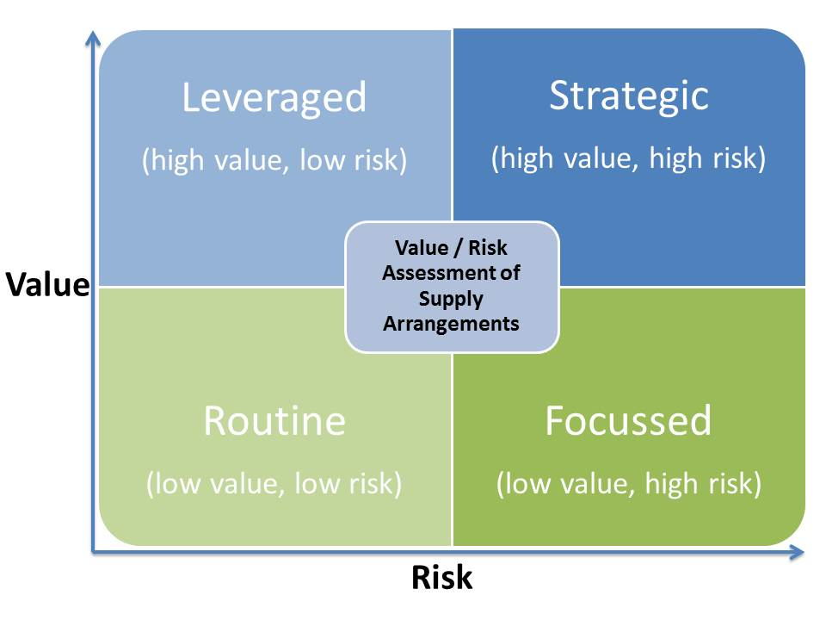Will this extension/renewal result in: An extension of time Increase in costs (spend)
(tick all that apply) Change to the original scope
Commencement date of original contract:
Term of original contract:
How is this contract classified according to the value/risk matrix?
Routine Leveraged* Focused* Strategic*
* (Complete a Contract Review Report for extensions/renewals that are of significant value or duration)
Section 2 – Supplier performance
Satisfactory supplier performance: Yes No KPIs/service levels met: Yes No N/A
Please provide comments about the supplier(s) performance to date (including how you verified supplier performance):

Section 3 - Spend under contract
Original contract value: $ Spend under contract to date: $
Forecast-spend under contract extension/renewal period: $
Is there a Standing Offer Arrangement planned or in place (either across
whole-of-government or selected agencies) for these types of goods / services? Yes No
If so, is the supplier part of that Standing Offer/Panel Arrangement? N/A Yes No
Section 4 – Demand
What is the anticipated future demand for products or services? Has there been a change?
Is it consistent with/related to the original scope of works/services? Yes No (If not then explain below)
If the scope is not related or consistent with the original contract, explain the basis of your decision to extend / renew rather than go to market for the new scope:

Section 5 – Price/Market Review
Would reapproaching the market result in better value for money? Yes No (If not, explain why below)
Does the contract extension/renewal result in value for money? Yes No
What market research have you done?

Explain why/how value for money will be obtained/maintained by extending or renewing the contract:
What opportunities have been identified to improve value for money under the contract?

Section 6 - Consultation

Who have you consulted with regarding this extension/renewal request? (List stakeholders by name, position and identify which of them are key customers/buyers under the contract):

(Consider your key customers/buyers, Legal, Procurement, Category Managers, Procurement Transformation Division, or other stakeholders internal or external to your organisation).

Section 7 - Endorsement
I confirm there is a valid business need for this extension/renewal.
I confirm I have reviewed the market, explored the available procurement options and determined that this extension/renewal is the most appropriate option.
I confirm I have reviewed pricing and the cost associated with this extension/renewal is comparable to market rates.
I confirm this extension/renewal will continue to deliver outcomes which are consistent with, or improve achievement of, the objectives of the original contract.
I confirm the supplier(s) is/are performing satisfactorily under the existing contract arrangements.
I confirm a contract management plan/checklist has been created/updated for this extension/renewal.
I confirm I have completed a contract review report (if required).
I confirm this extension/renewal represents value for money for Queensland Government.

Recommended/Endorsed by: Signature:
Position/Role: Date:

Section 8 - Approval

I confirm I have the appropriate level of authority to approve the extension/renewal.

Approved by: Signature:
Position/Role: Date:

When to use this checklist

It is recommended you use this checklist for extension/renewal requests for all Routine contracts, and other contracts if the rationale for the extension/renewal can be adequately explained in the checklist (without the need for a contract review report - see below). It assists with record-keeping by providing an overview of facts and a record of endorsement and approval of the extension/renewal request.

This checklist may also be used instead of, or in conjunction with a contract review report which is recommended for contract extensions or renewals that are of significant value or duration, requiring a more detailed analysis and assessment of value for money.

This checklist and a contract review report can be used for individual or multiple contract extensions (e.g. contracts with multiple suppliers under a SOA). You do not have to complete one checklist/contract review report per contract.

Section 1 – Contract term

This provides a snapshot of the length of the contract, and extensions granted to date. Requests to extend contracts that have already been extended multiple times, or for a long duration should be reviewed carefully.

Use the value/risk matrix to determine whether the contract is classified as Routine, Leveraged, Focused or Strategic. High-value and high-risk contracts will require much more in-depth analysis than Routine contracts.

Section 2 – Supplier performance

There are a number of ways to assess supplier performance:
- obtain feedback from customers, e.g. by phone, email, surveys, meetings, about the supplier(s) performance and opportunities for improvement
- obtain feedback from suppliers about their performance against KPIs, milestones, service levels, etc. and seek feedback on their ideas for opportunities for improvement
- review reports and analyse performance data (either from the supplier or from the customer/category manager) about the supplier(s) performance, particularly against any KPIs, service levels. If there were concerns about supplier performance, have they been resolved?

Section 3 – Spend under contract

This provides a snapshot of the total value of the contract, including any extensions or renewals. Requests to extend contracts that have significantly exceeded the original contract value should be reviewed carefully.

Before extending or renewing a contract please check whether there are any existing agency or whole-of-government standing offer arrangements (i.e. supplier panels) in place that you can buy from instead.

The Queensland Contracts Directory contains a listing of SOAs across agencies. A new arrangement may have been put in place since the original contract was established.

If a SOA is in place but the supplier is not part of it, then solid grounds must exist demonstrating that the contract you are renewing or extending delivers better value for money, and approval from the relevant category manager should be sought. An Agency must disclose purchases outside of SOAs in its agency procurement plan, and to the Director-General Council in accordance with the Queensland Procurement Policy.

If you are aware of an intention to establish a SOA, please liaise with the relevant Agency/ Department to determine whether it is possible to defer or delay the extension, or to otherwise co-ordinate your activities.

Section 4 - Demand

You must verify that there is still a legitimate business need for the goods/services under the contract. Demand requirements may have changed since the original contract was established. If this is the case, then explain why demand has changed and how this impacts the contract.

If you have a new scope of work for the extended term then attach it to the checklist.

Section 5 – Price / Market review

The amount of supporting analysis required for price/market review will vary depending on the value and risk of the contract, e.g. high-value contracts will require evidence of benchmarking, but low-value contracts may only require basic enquiries like comparing quotes or prices from other suppliers.

Consider whether other procurement strategies, e.g. re-testing the market via select/open tender, might result in better value for money (or not).

Opportunities to improve value for money

Always seek opportunities to improve value for money under the contract, such as negotiating: cost reductions; improvements to quality of products or services; improved service levels/KPIs; improvements to scope at no additional cost, or other additional value-added services.

Section 6 – Consultation

Record which stakeholders you have consulted with in this review process. Identify the key customers/stakeholders.

Section 7 – Endorsement

By ticking the boxes in this section, you verify that:
- you have undertaken the analysis necessary to make an informed recommendation supporting the request for extension or renewal
- by granting the extension or renewal you are satisfied that the government will achieve the best value for money.

Section 8 – Approval

The approver is the person with the delegated authority to authorise the contract extension or renewal.

