DELETE THIS GUIDE NOTE

This schedule is to form part of the preliminaries section of the tender documents for ‘design and construct’ projects. Project Managers to complete as appropriate – the following is a guide only.

This schedule should not be included for “construct only” projects

The Project Manager must be mindful of the costs of tendering and ensure abortive design work by unsuccessful Tenderers is kept to a minimum.

Tender requirements for design and construct Tenderers:

Tenderers are required to submit as part of the tender the following:

A development proposal based on the tender documents. The development proposal is required to contain:

- a statement of the names of consultants which the Tenderer proposes to engage and the extent of services envisaged;

- a time program indicating all activities occurring during the time required for the execution of the work under the Contract, including design development, documentation, construction and commissioning activities;

- the projected cash flow;

- an architectural sketch plan of the proposed site development and surrounding infrastructure to a minimum scale of 1:500;

- architectural sketch plans, elevations and typical sections of the building(s) to a minimum scale of 1:200;

- civil/structural schematic drawings to a minimum scale of 1:200;

- schematic drawings for mechanical, electrical, fire and other services to a minimum scale of 1:200;

- schedules of finishes; and

- schedules of fixtures, fittings and equipment including quantities, brand names, model numbers and costs.

CONDITIONS OF TENDER AND CONDITIONS OF CONTRACT FOR MEDIUM WORKS

(WITH DESIGN RESPONSIBILITY)

CONDITIONS OF TENDER

- The tender documents comprise the tender form, letter of invitation to tender (if any), these Conditions of Tender, the Code of Tendering (AS4120 - 1994) as amended by these Conditions of Tender, these Conditions of Contract for Medium Works and such specifications, drawings and any other information issued by the Principal for the purposes of tendering and which may be inspected or obtained at the place of closing of tenders.

- For hardcopy tenders:

      - the tender shall be signed, fully priced where required and accompanied by any other documents required to be submitted including without limitation a completed Compliance Submission in the form attached at Schedule 2 to the Conditions of Tender; and

      - the tender must be enclosed in an envelope, sealed and endorsed with the location and description of the work and reference number (if any) and lodged at the place named in the tender form (tender box), by the date and time given. Any tender, or part thereof, not in the tender box before the specified closing time may be rejected at the discretion of the Principal.

In exercising its discretion as to rejection of any tender, the Principal shall, amongst other factors, consider any evidence that the tender was sent by prepaid post or recognised carrier in time to be delivered, within the time stated, in the ordinary course of mail or delivery by the recognised carrier.

- For electronic tenders (if applicable):

      - the tender shall include a completed tender form, be fully priced where required and accompanied by any other documents required to be submitted including without limitation a completed Compliance Submission in the form attached at Schedule 2 to the Conditions of Tender;
      - the tender must be lodged electronically at the place named in the tender form for electronic tenders by the date and time given; and
      - an electronic tender shall be deemed to have been delivered to the Department of Housing and Public Works’ information system designated to receive the electronic communications at the date and time stated on the electronic receipt issued to the Tenderer. Any electronic tender, or part thereof, that has not been delivered to the designated information system before the specified closing time may be rejected at the discretion of the Principal.

- A tender received by a means other than expressly provided for in these Conditions of Tender may not be considered.

- The Tenderer is required to satisfy itself as to the correctness and sufficiency of its tender. A tender shall be deemed to be on the basis that the Tenderer has a full knowledge of all matters relating to the Contract and has undertaken an inspection of the site and any existing structures or features thereon.

- The Principal shall not be bound by any oral advice or information furnished in respect of the tender but shall be bound only by written advice or information given or furnished by it (which may be given electronically).

- Notwithstanding the evaluation of tenders (if any) in accordance with clause A8, the Principal shall not be bound to accept the lowest or any tender. The Principal may in its absolute discretion consider, accept or decline to accept any tender. A tender shall not be deemed to have been accepted until the date of notification in writing to the Tenderer of such acceptance.

- The Principal shall evaluate tenders that comply with the requirements of the tender documents (‘conforming tenders’) in accordance with the tender evaluation criteria contained in Schedule 1 to the Conditions of Tender or, in the absence of Schedule 1, on the basis of best “value for money” in accordance with the Queensland Procurement Policy. The Principal, if it determines to evaluate an alternative tender (being a tender that is not a conforming tender), shall evaluate such tenders on the basis of best “value for money” in accordance with the Queensland Procurement Policy which may, or may not, be the tender evaluation criteria contained in Schedule 1. Where both conforming and alternative tenders have been evaluated, the Principal may accept a tender which on a consideration of all the circumstances appears to be the best “value for money” for the Queensland Government.

- Without derogating from clause A8 and notwithstanding clause 6.6 of AS4120-1994, in the evaluation of tenders (if any), the Principal may, without being under any obligation to do so, in its absolute discretion and at any time, seek clarification in respect of any aspect of a tender, shortlist or prefer any one or more tenderers, and discuss or negotiate with or receive best and final offers from any one or more tenderers, in such a manner and as to such aspects of the tender, as the Principal determines.

- The Tenderer shall have in place the quality system nominated by the Principal in the Contract (if any).

- Notwithstanding that the Principal may have invited tenders from selected organisations or has otherwise procured submission of tenders, the Tenderer acknowledges that the Principal may decline to consider or accept a tender from a Tenderer who has not been able to satisfy the Principal that it has sufficient financial capacity to satisfactorily perform and complete the Contract in accordance with its terms. The Tenderer may be requested to provide financial information to the Queensland Building and Construction Commission for the purpose of an assessment by the Principal as to the Tenderer’s financial capacity and a failure to provide the requested information, within seven (7) days of such a request, may result in a decision by the Principal that the Tenderer does not have sufficient financial capacity to satisfactorily perform and complete the Contract in accordance with its terms.

- The Principal may decline to consider or accept a tender from a Tenderer who, prior to the award of a tender, does not hold a Certificate of Prequalification, or is not appropriately registered for the work the subject of the tender, pursuant to the Prequalification (PQC) System released and current at the time and date at which tenders were invited.

- If required by the tender documents, the Tenderer acknowledges and agrees that if awarded a Contract as a result of submitting a tender, it shall comply with the requirements of the Working with Building and Asset Services document and, prior to commencing the Works, be registered as a Building and Asset Services Registered Contractor.

- The Right to Information Act 2009 (RTI Act) provides members of the public with a legally enforceable right to access documents held by Queensland Government agencies. The RTI Act requires that documents be disclosed upon request, unless the documents are exempt or on balance, disclosure is contrary to public interest.

- Information contained in a tender is potentially subject to disclosure to third parties. In the assessment of any disclosure required by the Principal pursuant to the RTI Act, the Tenderer accepts that any information provided in its tender, including information marked as confidential, will be assessed for disclosure in accordance with the terms of the RTI Act.

- Notwithstanding any other provision of the tender documents or a tender, if a tender is accepted, the Principal may publish on a Queensland Government website or by any other means, Contract information including:
(i) the name and address of the Principal and the successful Tenderer;
(ii) a description of the goods and/or services to be provided pursuant to the Contract;
(iii) the date of award of Contract (including the relevant stages if the Contract involves more than one stage);
(iv) the Contract value (including the value for each stage if the Contract involves more than one stage and advice as to whether any non-price criteria were used in the evaluation of tenders); and
- the procurement method used.

- For open tenders, the Principal may publish the names of all Tenderers and the lump sum tender sums tendered.
- The law governing the tender documents and any subsequent contract, if applicable, is the law of Queensland and the parties submit to the non-exclusive jurisdiction of the Courts of Queensland.
Tenderers must note:

- that:
    - if the Tenderer is awarded a Contract, the Principal will, in accordance with the Prequalification (PQC) System, prepare and submit performance reports to the PQC Registrar. The performance reports may include, amongst other things, information regarding;
        - achievements or compliance with representations made in response to evaluation criteria listed in Schedule 1 to the Conditions of Tender;
        - compliance with any legislation relating to workplace health and safety, industrial relations, taxation and workers compensation legislation; and
        - compliance with the provisions of the Contract, including those clauses concerning Subcontracting (clause 5), Occupational Health and Safety Audit (clause 7.2), Indigenous Employment Policy (clause 9), Site Personnel Register (clause 8) and Payment of Workers and Subcontractors (clause 28);

      - the Queensland Government has published a document entitled “Queensland Code of Practice for the Building and Construction Industry”(the Code of Practice). Tenderers are reminded that by being registered pursuant to the Prequalification (PQC) System they have provided an undertaking that they will abide by the Code of Practice;

      - an adverse performance report or non-compliance with the Code of Practice will result in a review of the Contractor’s PQC registration status;

      - an adverse performance report noting non-compliance with the Indigenous Employment Policy clause 9 may result in a decision by the State to preclude the Tenderer from further tendering for work in Indigenous communities in Queensland,
- where the work under the Contract involves ‘residential construction work’ (as that term is defined in the Queensland Building and Construction Commission Act 1991), payment of the required insurance premium must be made to the Queensland Building and Construction Commission. The cost of complying with that obligation shall be deemed to be included in the Tender.

Schedule 1 to the Conditions of Tender – Tender Evaluation

Principal’s Determination

The Principal shall determine whether a tender is an alternative tender or conforming tender and, in doing so, shall have regard to:

1. whether the tender contains errors of an administrative nature which do not amend or change the substance of the offer;

2. whether the tender contains clarification of an ambiguity; and

3. the extent to which the tender does not contain all of the documents required by the tender documents to be submitted including without limitation a completed Compliance Submission in the form attached at Schedule 2 to the Conditions of Tender.

In making a determination, the Principal’s consideration shall not be limited to the matters nominated at 1, 2 and 3 above.

Where, in addition to the Tender Sum, the Tenderer is required to submit information addressing other tender evaluation criteria, if Tenderer fails to address any of the criteria then the Tender shall be deemed to be an alternative tender.

Any tender that contains qualifications shall be deemed to be an alternative tender.

In the event that the tender contains an ambiguity in relation to the Tender Sum, then the amount in words on the Tender Form shall prevail.

Tender Evaluation Criteria – Conforming Tenders

Criterion 1. Tender Sum Weighting [70]%

Criterion 2 Indigenous Employment Policy Compliance Weighting [30]%

The ‘Indigenous Employment Policy for Queensland Government Building and Civil Construction Projects (IEP 20% Policy)’ (IEP Policy) is applicable to this project. A copy of the IEP Policy can be located at http://www.training.qld.gov.au/industry/indigenous-employment-policy/index.html.

The IEP Policy aims to promote, encourage and create skills development, employment, and business opportunities for Aboriginal and Torres Strait Islander people in relation to Queensland Government building projects. The IEP Policy requires either, an agreed plan as to how the Contractor will engage with the local Indigenous community in carrying out the project through its employment and training of the local Indigenous workforce including apprentices and use of local enterprises in the supply of goods and services, or a 20% minimum benchmark of total labour hours, calculated in accordance with the IEP policy, be provided by the local Indigenous workforce. The Principal is seeking to maximise the involvement of the local Indigenous workforce on this project above the 20% benchmark stated in the IEP Policy.

In submitting a tender, Tenderers are expected to address this criterion and include, as a minimum:

• Overall methodology for compliance with the IEP Policy and clause 9 of the Conditions of Contract including completion of a Compliance Submission in the form attached at Schedule 2 to these Conditions of Tender;
• Strategies to achieve better than 20% of the total labour hours being provided by the local Indigenous workforce.
Schedule 2 to the Conditions of Tender – Compliance Submission
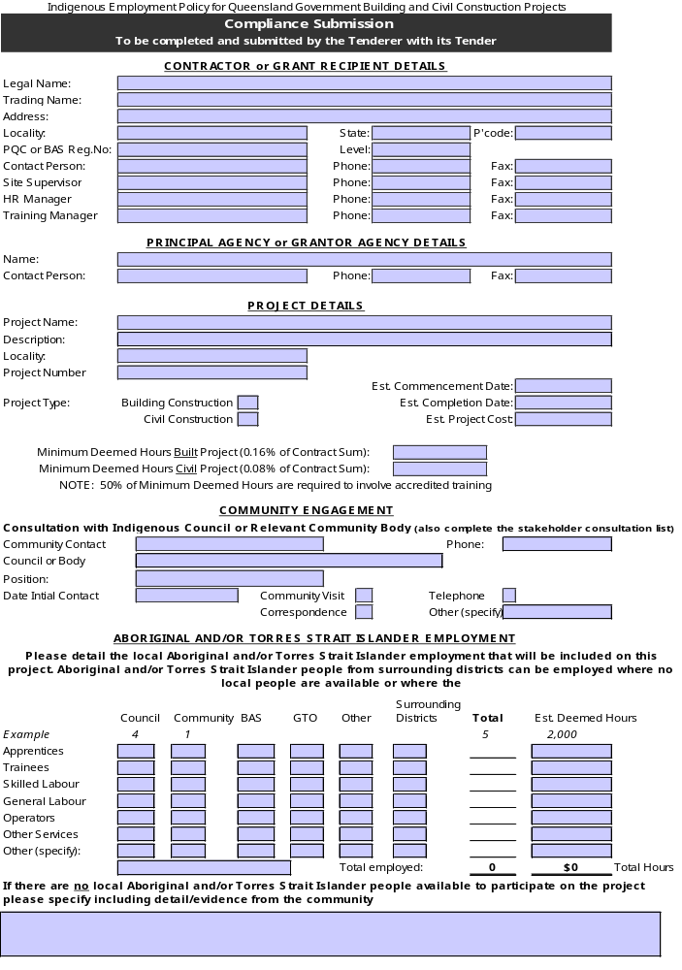
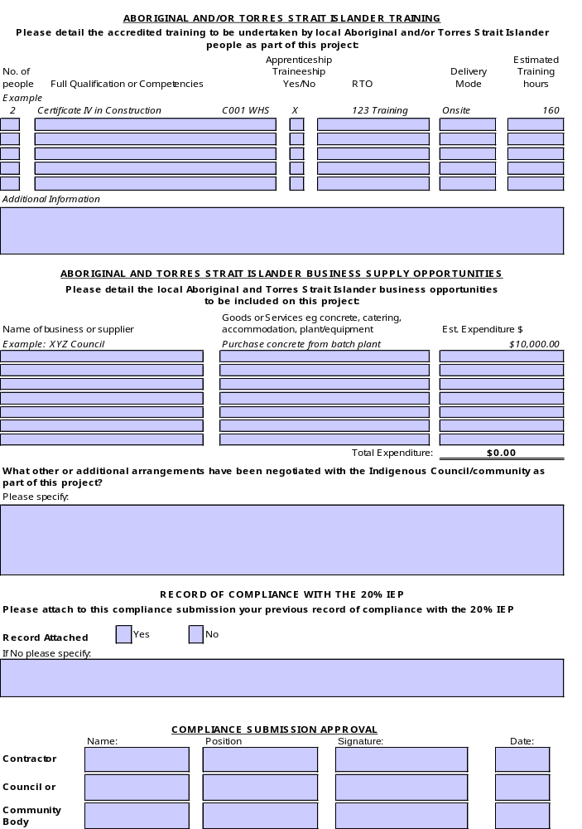
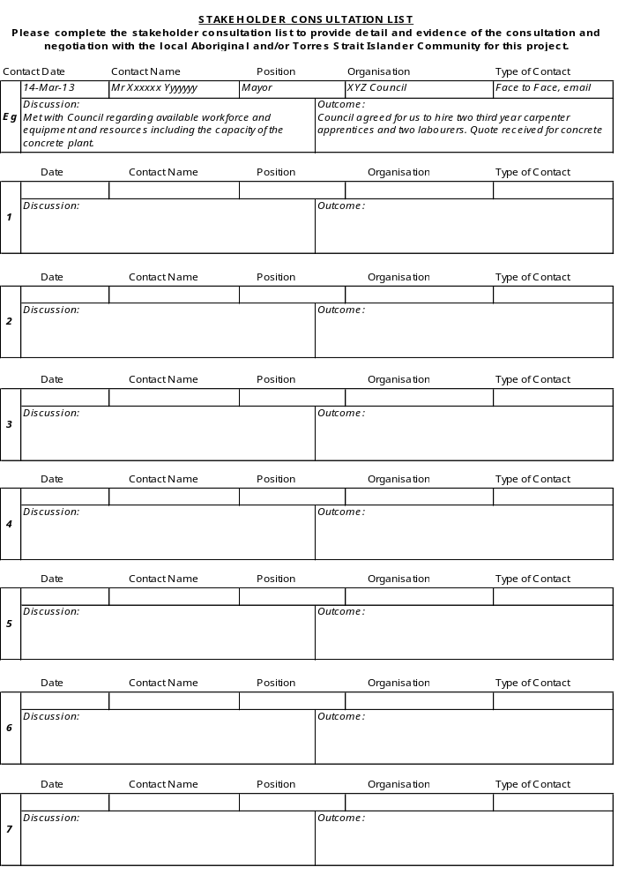

CONDITIONS OF CONTRACT

- DEFINITIONS

The following definitions apply to this Contract:-

“Building Certifier” means the person nominated in the Annexure;

“Contract” means the agreement in writing between the Principal and the Contractor for the execution of the work under the Contract, including the tender documents;

“Contractor” means the person or company whose tender for the work under the Contract has been accepted and its executors, administrators, successors or permitted assigns;

“Date for Practical Completion” means the date, or last day of the period of time, specified in the Annexure.

“Practical Completion” means the work under the Contract is complete in accordance with the Contract except for minor omissions and defects which will not (and the rectification of which will not) prevent or impair the normal use and occupation of the Works;

“Principal” means the person identified as the Principal in the Annexure;

“Site” means the land and other places to be made available and other lands and places made available to the Contractor by the Principal for the purpose of the Contract;

“Superintendent” means the person nominated by the Principal to exercise the functions of the Superintendent under the Contract. The Superintendent may appoint a Representative to exercise any of its powers, duties, discretions and authorities;

“work under the Contract” means the work which the Contractor is or may be required to execute under the Contract including any variations;

“Works” means the whole of the work to be executed and completed in accordance with the Contract, including all variations provided for by the Contract, which by the Contract is to be handed over to the Principal.

- EXECUTION OF WORKS

The Contractor shall undertake the Works in accordance with the Contract and any other documents issued by the Principal. Unless otherwise provided, the Contractor is responsible for all things, including items not expressly mentioned in the Contract, necessary for satisfactory completion of the Works. The documents forming the Contract are mutually explanatory and anything contained in one but not in another is equally binding as if contained in all.

If the Contractor discovers any ambiguity or discrepancy in any document forming the Contract it shall notify the Superintendent in writing as soon as practicable. In the event of an ambiguity or discrepancy, the Superintendent shall direct the Contractor as to the interpretation to be followed in carrying out the Works.

The Contractor shall comply with the requirements of all laws and public or other authorities affecting the Works, and unless otherwise specified pay all fees, give all notices and obtain necessary consents.
- DESIGN RESPONSIBILITY
  - The Contractor shall:

    - complete the design and documentation of the Works, including drawings and trade specifications, in accordance with the Contract and all relevant legislative requirements; and
    - ensure that materials and standards of workmanship prescribed in drawings, trade specifications and other documents are fit for the purpose specified in the tender documents, and are consistent with the nature and character of the Works and in accordance with the Contract.
  - The Contractor warrants to the Principal that:
    - The Contractor will exercise the degree of skill, care and diligence expected of a competent design professional in carrying out the design and documentation of the Works; and
    - the design of the Works will comply with the Contract and will in all respects be fit for the purpose specified in the tender documents.
  - The Contractor shall remain responsible for the design of the Works notwithstanding any approval given under the Building Act 1975 or any review or approval of the design undertaken by or on behalf of the Principal.
  - The Contractor acknowledges that the Principal is relying on the Contractor’s skill and expertise in undertaking the design and construction of the Works.
- BUILDING CERTIFIER
  - The Building Certifier is the authority for the purposes of approval under the Building Act 1975. In the performance of its duties, the Building Certifier acts as an independent party and not as an agent of the Principal.
  - The Contractor shall be responsible for obtaining approval under the Building Act 1975 in respect of the design of the Works. For this purpose, the Contractor shall pay all fees and submit to the Building Certifier all material necessary for obtaining such approval. The Contractor shall allow a minimum of 28 days for approvals under the Building Act 1975.
  - During construction of the Works, the Contractor shall arrange for the plumbing and drainage installations to be inspected by all relevant authorities and all associated fees shall be paid by the Contractor.
  - Approvals and certificates issued by relevant authorities shall be provided to the Principal as soon as possible following Practical Completion.
- ASSIGNMENT AND SUBCONTRACTING

The Contractor shall not assign or subcontract the work under the Contract, any part thereof, or any benefit thereunder without the prior written approval of the Superintendent. The Contractor shall not, without the prior written approval of the Superintendent, allow a subcontractor to subcontract work under the Contract. The Superintendent may, in its entire discretion and without giving reasons, reject any request for approval by the Contractor pursuant to this clause. All requests for approval to subcontract or subcontract pursuant to this clause must be made by the Contractor to the Superintendent in the form provided in Schedule 1.

- WORK HEALTH AND SAFETY ACT 2011

  - For the purposes of this clause:

‘Act’ means the Work Health and Safety Act 2011 (Qld), as amended from time to time;

‘Regulation’ means the Work Health and Safety Regulation 2011 (Qld), as amended from time to time;

‘workplace’, ‘inspector’, ‘notifiable incident’, ‘principal contractor’, ‘structure’ and ‘regulator’ have the same meanings as in the Act.

  - From the Date of Acceptance of Tender:
    - the Principal engages the Contractor to be the principal contractor under the Regulation in relation to the work under the Contract and authorises the Contractor to:
(i) have management and control of the workplace at which the work under the Contract is being undertaken including the Site; and
(ii) discharge the duties of the principal contractor under the Regulation; and
    - the Contractor accepts the engagement as principal contactor and agrees to fulfil all requirements and give effect to that engagement prior to commencing any of the work under the Contract; and
    - the Contractor will comply with and discharge all obligations imposed on the Contractor, as principal contractor, as a person who conducts a business or undertaking and otherwise, by the Act, the Regulation and any other regulation in connection with health and safety; and
    - the Contractor will consult with the Principal and will consult with the designers of the whole or any part of a structure to be constructed under the Contract, about how to ensure that risks to health and safety arising from the design are eliminated during construction of the work under the Contract or, if it is not reasonably practicable to eliminate the risks, minimise, so far as is reasonably practicable; and
    - the Contractor will, in performing its obligations under the Contract, take into account and take appropriate action having regard to any information given to the Contractor by the Principal or any other person, about hazards and risks at or in the vicinity of the workplace where the work under the Contract is being carried out.

  - The Contractor will indemnify the Principal against any claim, action, demand, loss, damage, cost or expense which may be brought against, or suffered or incurred by, the Principal as a result of or in connection with:
    - any breach of this clause by the Contractor;
    - any breach by the Contractor of its obligations under the Act, the Regulation or any other regulation in connection with health and safety;
    - any enforcement of obligations imposed on the Contractor under the Act, the Regulation or any other regulations.

  - If a notifiable incident occurs at the workplace at which the work under the Contract is being undertaken, the Contractor must:
    - immediately notify the regulator and the Superintendent of the notifiable incident; and
    - take all reasonably practicable steps to secure the Site where the notifiable incident occurred until an inspector arrives at the Site or any earlier time that an inspector directs.

- PROTECTION OF PERSONS AND PROPERTY

  - Protection Measures

The Contractor shall take all measures necessary to protect people and property, including the Works, avoid unnecessary interference with passage of people and vehicles, prevent nuisance, unreasonable noise and disturbance. If the Contractor damages any property, the Contractor shall provide temporary protection for, and repair it at its cost.

  - Occupational Health and Safety Audit

    - This clause 7.2 will not apply unless noted applicable in the Annexure.

    - In this Clause 7.2, the term “Accredited Auditor (Construction)” means a person accredited by Workplace Health and Safety Queensland as an occupational health and safety auditor to undertake auditing pursuant to the Work Health and Safety Act 2011.

    - Within 14 days of the date of acceptance of tender, the Contractor must engage an Accredited Auditor (Construction) to perform the functions specified in the Contract.

    - The cost of performance by the Accredited Auditor (Construction) of the required functions will be reimbursed by the Principal in accordance with the provisions specified in the Contract. The reimbursable amount will be a debt due from the Principal to the Contractor.

    - The Contractor must ensure that the Accredited Auditor (Construction) engaged under Clause 7.2(c) has not:

      - in the two years prior to the date of acceptance of tender, had a business or employment relationship with the Contractor including without limitation where the Accredited Auditor (Construction) has, either personally or as an employee or an agent of another person or entity, been involved in the development and/or maintenance of the Contractor’s occupational health and safety management system in any capacity other than by reason of having been engaged as an Accredited Auditor (Construction); or
      - been engaged by the Contractor as an Accredited Auditor (Construction) more than three times within a 12 month period to perform the functions specified in the Contract.

    - The Contractor must provide copies of all reports and any corrective action notices received from the Accredited Auditor (Construction) to the Superintendent within three days of receipt. In relation to corrective action notices, in addition to any other avenues available under the Contract:

      - the Superintendent may direct the Contractor, by written notice, to carry out any required corrective action within the time specified in the Superintendent’s notice; or
      - the Principal may take all necessary urgent action to protect the work under the Contract, and the cost incurred by the Principal shall be a debt due from the Contractor..

    - A direction given under Clause 7.2(f)(i) constitutes a direction under clause 16. If such a direction is given, the Contractor must inform the Superintendent in writing immediately upon completion of the corrective actions.”

- SITE PERSONNEL REGISTER
  - From the commencement of work under the Contract until Practical Completion, the Contractor must maintain a register in the form in Schedule 2 (‘Site Personnel Register’) of all individuals who carry out work under the Contract on Site.
  - The Site Personnel Register must be available for inspection at all times by the Superintendent.
  - The Contractor must provide statistical information in the form in Schedule 2 (“Site Personnel Register Summary”) to the Superintendent every 13 weeks and at such other times as the Superintendent may direct.
  - Failure to comply with this clause 8 constitutes a substantial breach of contract.

- ENGAGEMENT OF INDIGENOUS COMMUNITY WORKERS
Interpretation
  - For the purposes of this clause 9:
(a) ‘accredited training’ means a program through which:
(i) competencies are specified and lead to the attainment of a nationally recognised qualification;
(ii) learning is planned, organised and sequenced in order to assist the apprentice/ trainee achieve workplace competence;
(iii) methods of training delivery appropriate to the achievement of competence are chosen;
(iv) quality training resources are used to assist the apprentice/trainee learn; and
(v) assessment events are planned and undertaken at appropriate points throughout the traineeship;
(b) ‘apprentices/trainees’ includes any workers engaged in the following arrangements:

- a formal apprenticeship or formal traineeship as provided for in State vocational education and training legislation that results in a nationally recognised building and construction qualification;
(ii) a cadetship or scholarship incorporating formal tertiary professional or technical education that results in a nationally recognised building and construction qualification; or
(iii) such other training program as may be acceptable to the Principal;

(c) 'CSQ' means the Building and Construction Industry Training Fund, trading as Construction Skills Queensland or such other entity having responsibility for administering the ‘Indigenous Employment Policy for Queensland Government Building and Civil Construction Projects (IEP 20% Policy)’;

(d) ‘IEP Policy’ means the ‘Indigenous Employment Policy for Queensland Government Building and Civil Construction Projects (IEP 20% Policy)’ a copy of which can be located at http://www.training.qld.gov.au/industry/indigenous-employment-policy/index.html;

(e) ‘local Indigenous community’ means the community within the boundary of the local Council for the relevant Aboriginal and Torres Strait Islander communities specified in the IEP Policy.

Compliance Plan
  - The Contractor must prepare a Compliance Plan and submit it in accordance with clause 9.5. Subject to clause 9.3, the Compliance Plan must be based on the tendered Compliance Submission accepted by the Principal. The Contractor must obtain the approval of the applicable local Indigenous community or Council to its Compliance Plan.
  - Where the Contractor proposes a Compliance Plan different from the Compliance Submission included in the Contractor’s Tender and accepted by the Principal, or if there is no accepted Compliance Submission, the Contractor must, prior to having its Compliance Plan approved by the applicable local Indigenous community or Council, seek the Principal’s approval of the proposed Compliance Plan. The Principal may in its absolute discretion reject any such request by the Contractor.

IEP Policy Compliance
  - The Contractor, in its execution of the work under the Contract, either directly or indirectly through subcontractors, and in consultation with the local Indigenous community, shall comply with the IEP Policy and the Compliance Plan submitted in accordance with clause 9.5.

Submission of Forms
  - The Contractor must:

- within 20 Business Days of the Date of Acceptance of Tender, submit to CSQ, with a copy to the Superintendent, a completed Compliance Plan in the form attached to these Conditions at Schedule 3, signed and approved by the applicable local Indigenous community or Council;

- within 5 Business Days of the first day of each month, submit to CSQ, with a copy to the Superintendent, a completed Interim Compliance Report in the form attached to these Conditions at Schedule 3;

- if the Contractor makes a payment claim under the Contract in the same month in which the Contractor’s Tender is accepted, submit to CSQ, with a copy to the Superintendent with the Contractor’s first payment claim, a completed Interim Compliance Report in the form attached to these Conditions at Schedule 3; and

- within 10 Business Days of the Date of Practical Completion, or if there is more than one, the last occurring Date of Practical Completion, submit to CSQ, with a copy to the Superintendent, a completed Practical Completion Compliance Report in the form attached to these Conditions at Schedule 3.

Alternative Compliance Plan
  - Where a Compliance Plan is not submitted in accordance with clause 9.5(a), the Contractor shall, unless and until an alternative Compliance Plan is submitted to the satisfaction of the Principal, in its execution of the work under the Contract, either directly or indirectly through subcontractors and in consultation with the local Indigenous community, engage Indigenous workers from the local Indigenous community for the number of labour hours no less than the number derived by multiplying the accepted GST inclusive Contract Sum by 0.16%: viz

GST inclusive Contract Sum x .16% = number of labour hours.

A minimum of 50% of the labour hours calculated pursuant to this clause 9.6 shall be performed by apprentices/trainees or other employees from the local Indigenous community, undertaking accredited training.

Where this clause 9.6 applies, the Contractor must submit to CSQ with a copy to the Superintendent a Compliance Plan in the form attached to these Conditions at Schedule 3identifying compliance with ‘minimum deemed hours’.

Statutory Declaration
  - The Contractor must, prior to making each payment claim under the Contract, deliver to the Superintendent a statutory declaration in the form attached to these Conditions at Schedule 3, or where the Contractor is a corporation, by the representative of the Contractor who is in a position to know the facts attested that:

(a) the Interim Compliance Report/s has been completed by the Contractor setting out their monthly progress of compliance with the IEP Policy and the Compliance Plan submitted in accordance with this clause 9;

(b) the completed Interim Compliance Report/s has been provided to CSQ with a copy to the Superintendent in accordance with clause 9.5(b); and

if requested in writing, reasonable supporting documentary evidence thereof.

Failure to comply
  - If the Superintendent is informed by CSQ, or such other entity or agency having responsibility for administering the IEP Policy, of a failure by the Contractor to comply with any of the Contractor’s obligations set out in this clause 9, the Superintendent may take action under the Contract as appropriate.
  - The Contractor acknowledges that failure to comply in part or in whole with the requirements of this clause 9 will constitute a substantial breach of contract and may result in a decision by the Principal (the State of Queensland) to preclude the Contractor from further tendering for work in Indigenous communities in Queensland.

- CARE OF WORK AND REINSTATEMENT OF DAMAGE

The Contractor shall be responsible for the care of the whole of the work under the Contract. If loss or damage occurs to the work under the Contract, the Contractor shall at the Contractor’s cost rectify such loss or damage except loss or damage caused by the negligent act or omission of the Principal, or employees or agents of the Principal, or caused by defects in the design of the work under the Contract.

- INDEMNITY BY THE CONTRACTOR

The Contractor indemnifies the Principal against:-

    - Loss of or damage to the Principal’s property; and

    - Claims by any person in respect of injury, death or loss of or damage to any property,

resulting from or in any way connected with the Contractor carrying out the work under the Contract, but the Contractor’s liability to indemnify the Principal shall be reduced proportionally to the extent that an act or omission of the Principal, or its employees or agents, contributed to the loss, damage, death or injury.

- INSURANCE OF WORKS

This clause 12 will apply unless otherwise noted in the Annexure.

Before the Contractor commences work, the Contractor shall take out an insurance policy covering all the things referred to in clause 10 against loss or damage resulting from any cause whatsoever until the Contractor ceases to be responsible for their care.

The insurance cover may exclude—

    - the cost of making good fair wear and tear or gradual deterioration but shall not exclude the loss or damage resulting therefrom;
    - the cost of making good faulty design, workmanship and materials but shall not exclude the loss or damage resulting therefrom;
    - consequential loss of any kind, but shall not exclude loss of or damage to the Works;
    - damages for delay in completing or for the failure to complete the Works;

The Excepted Risks are—

      - any negligent act or omission of the Principal, the Superintendent or the employees, consultants or agents of the Principal;
      - any risk specifically excepted in the Contract;
      - war, invasion, act of foreign enemies, hostilities, (whether war be declared or not), civil war, rebellion, revolution, insurrection or military or usurped power, martial law or confiscation by order of any Government or public authority;
      - ionising radiations or contamination by radioactivity from any nuclear fuel or from any nuclear waste from the combustion of nuclear fuel not caused by the Contractor or the Contractor’s employees or agents;
      - use or occupation by the Principal or the employees or agents of the Principal or other contractors to the Principal (not being employed by the Contractor);
      - Nominated Subcontractor engaged by the Principal pursuant to a prior contract the benefit of which has been assigned to the Contractor pursuant to the Contract) of any part of the Works or the Temporary Works;
      - defects in the design of the work under the Contract other than a design provided by the Contractor.

- PUBLIC LIABILITY AND PROFESSIONAL INDEMNITY INSURANCE

Before commencing work the Contractor shall have:

    - public liability insurance for an amount not less than ten million dollars ($10,000,000) or such other amount required by the Principal, covering the Contractor’s liability to the Principal for loss of or damage to property and death or injury to any person; and
    - professional indemnity insurance for not less than two million dollars ($2,000,000) or such other amount required by the Principal.
The Contractor shall maintain the insurance policies required by this clause 13 for the duration of the Contract and produce evidence of insurance if requested.

Failure by the Contractor to provide evidence of insurance shall constitute a substantial breach of the Contract by the Contractor.

- INSURANCE OF EMPLOYEES (WORKCOVER)

Before commencing work the Contractor shall have insurance of employees. The Contractor shall maintain such insurances for the duration of the Contract and produce evidence of insurance if requested. The Contractor shall ensure that every subcontractor is similarly insured.

Failure by the Contractor to provide evidence of insurance shall constitute a substantial breach of the Contract by the Contractor.

- PROVISIONAL SUMS

A provisional sum or rate included in the Contract shall not itself be payable by the Principal but where at the direction of the Superintendent the work or item to which the provisional sum or rate relates is performed, supplied or incurred the work or item shall be assessed by the Superintendent pursuant to clause 27. The margin for profit and attendance shall be 12.5%.

- MATERIALS AND WORKMANSHIP

All materials used in any work under the Contract and the standards of workmanship shall be in conformity with the provisions of the Contract. In the absence of such provisions in the Contract the material or standard of workmanship as the case may be shall be of a kind which is suitable for its purpose and is consistent with the nature and character of the Works. Unless otherwise specified, all materials shall be new and workmanship shall be in accordance with the relevant manufacturer's recommendations or, if none, the relevant Australian Standard where applicable. Apart from any tests specified, the Superintendent may at any time direct that any materials or work shall be examined and/or tested.

The Contractor shall comply with any direction by the Superintendent to remedy any work not in accordance with the Contract within the period of time stipulated in writing by the Superintendent. If the Contractor fails to comply with such a direction to carry out rectification work within the time stipulated, the Principal may have the rectification work the subject of the direction carried out by others at the Contractor’s expense or may accept the work at a reduced value. The Principal may deduct the cost of rectification work or reduced value from payments or recover the cost or reduced value as a debt due from the Contractor. The Principal may deduct the estimated cost of rectification work from payments until such time as the Principal has incurred the cost of rectification.

- TIME FOR COMMENCEMENT

The Contractor shall commence work under the Contract within the time stated in the Annexure and shall, unless otherwise permitted, give at least two days notice to the Superintendent prior to the commencement of work.

- TIME FOR COMPLETION

The Contractor shall execute the Works to Practical Completion by the Date for Practical Completion or within any extended time agreed in writing by the Superintendent. The Principal’s entitlement to retention moneys (if any) shall be reduced to the percentage provided for in the Annexure or, if no percentage is stated, to 50% thereof, when the Contractor has achieved Practical Completion as certified by the Superintendent.

- EXTENSION OF TIME FOR PRACTICAL COMPLETION
  - The Contractor shall be entitled to an extension of time if it is or will be delayed in reaching Practical Completion by the Date for Practical Completion by:

    - any act, default or omission of the Principal, the Superintendent or an employee, contractor or agent of the Principal; or

    - those causes other than:

      - acts or omissions of the Contractor (including its employees, agents and subcontractors); and
      - industrial conditions or inclement weather occurring after the Date for Practical Completion,

and within 28 days after the delay occurs the Contractor gives the Superintendent a written claim for an extension of time for Practical Completion setting out the facts on which the claim is based.
  - Where more than one event causes concurrent delays and the cause of at least one of those events does not entitle the Contractor to an extension of time, then to the extent that the delays are concurrent the Contractor shall not be entitled to an extension of time for Practical Completion.
  - The Superintendent may extend the Date for Practical Completion for any reason.

- DELAY OR DISRUPTION COSTS
Where the Contractor has been granted an extension of the time under Clause 19 for any delay or disruption caused by the Superintendent, the Principal or the Principal's other contractors, employees, consultants, or agents, the Principal shall pay the Contractor extra costs at the daily rate worked out in accordance with the following formula:

(6.5% of the contract sum (exclusive of GST) ÷ (5 x the period of time (in weeks) for Practical Completion as per Clause 18)

Nothing in this Clause shall oblige the Principal to pay extra costs for delay or disruption which have already been included in the value of a variation or any other payment under the Contract.

- SEPARABLE PORTIONS

The Superintendent may, at any time, determine that a part of the Works will be regarded as a separable portion. The interpretations of:

    - Practical Completion; and
    - clauses 10, 19, 20, 22, and 23,

shall apply separately to each separable portion and references therein to the Works and to work under the Contract shall mean so much of the Works and the work under the Contract as is comprised in the relevant separable portion.

- LIQUIDATED DAMAGES

If the Contractor fails to complete the Works by the Date for Practical Completion together with any extensions of time granted by the Superintendent, the Contractor shall be liable to the Principal for liquidated damages in the amount stated in the Annexure for every day after that date until Practical Completion has been achieved or the Contract terminated, whichever is sooner.

- DEFECTS LIABILITY PERIOD

The Contractor shall promptly rectify all defects and omissions notified to the Contractor during the defects liability period stated in the Annexure. If the Contractor fails to do so, the Principal may have the omission or defect remedied by other persons and the cost so incurred shall be a debt due to the Principal which may be deducted from payments.

- CLEANING OF SITE

The Contractor shall keep the Site and the Works clean and tidy and regularly remove from the Site rubbish and surplus material arising from the execution of the Works. On completion of the Works the Contractor shall clear away and remove from the Site all constructional plant, surplus materials, rubbish and temporary works of every kind.

- VARIATIONS

The Superintendent may direct in writing a variation to any work under the Contract and the Contractor shall promptly comply with that direction. The Contractor shall submit to the Superintendent a detailed price for the variation within 14 days of the direction. The variation shall be valued by agreement between the Contractor and the Superintendent or failing agreement, by the Superintendent, and the Contract price adjusted accordingly. The margin for profit and attendance shall be 12.5%. No payment for additional work shall be made unless the additional work is authorised in writing by the Superintendent.

- LATENT CONDITION

If the Contractor discovers physical conditions on the Site or its surroundings, excluding weather conditions, which differ materially from those which should reasonably have been anticipated at the time of tender if it had –

    - examined all information made available in writing by the Principal to the Contractor for the purpose of tendering; and

    - examined all information relevant to the risks, contingencies and other circumstances having an effect on the tender and obtainable by the making of reasonable enquiries; and

    - inspected the Site and its surroundings,

The Contractor shall immediately notify the Superintendent in writing and may request that a variation be directed pursuant to clause 25.

The Superintendent may issue a direction in respect of the latent condition, and the Contractor shall be entitled to claim an extension of time for delays, and may be entitled to reimbursement of reasonable costs necessarily incurred as a consequence of the latent condition and directions issued in respect thereof.

- PAYMENT

Subject to the prior receipt by the Superintendent of the information required by clauses 9 and 28.2, at the times stated in the Annexure the Contractor shall give the Superintendent a detailed payment claim supported by information the Superintendent may reasonably require.

Within 10 business days after receipt of a claim for payment the Superintendent shall assess the claim and shall issue a payment certificate stating the amount of the payment to be made by the Principal or the Contractor. The Superintendent shall set out in a payment certificate the calculations employed to arrive at the amount certified and, if the amount is more or less than the amount claimed by the Contractor, the reasons for the difference.

Within 15 business days of receipt of the claim for payment, the Principal shall pay the amount certified by the Superintendent or the amount claimed, if the Superintendent has not so certified.

Payment shall take into account the deduction of retention moneys (if any) and any other amount which the Principal may be entitled to deduct or which is due and payable by the Contractor to the Principal whether under the Contract, any other contract or independent of contract. If the moneys to be deducted are insufficient to discharge the liability of the Contractor the Principal may have recourse to retention moneys or unconditional undertakings provided in lieu of retention.

Payment of moneys to the Contractor shall not be evidence of the value of work or an admission of liability or evidence that work has been executed satisfactorily but shall be a payment on account only. The Superintendent may by a later payment certificate correct an error in a previous payment certificate. Nothing in this Contract shall oblige the Principal to pay for work that is not in accordance with the Contract, or for plant or materials not incorporated in the Works on Site.

For the purposes of the Building and Construction Industry Payments Act 2004, the Superintendent is authorised to receive payment claims and to issue payment schedules on behalf of the Principal.

Retention moneys (if any) are for the purpose of ensuring the due and proper performance of the Contract and the Contractor may at any time provide in lieu of retention moneys, security in the form provided for in the Contract or such other form as approved by the Principal. If the Contractor has provided security in lieu of retention moneys, the Principal may at any time convert into money security that does not consist of money whether or not the Principal is then entitled to exercise a right under the Contract in respect of the security. The Principal shall not be liable in any way for any loss occasioned by such conversion.

Without limiting the Principal's rights under any other provision in the Contract and notwithstanding the provisions of or the issue of a certificate by the Superintendent under this clause 27, the Principal may deduct from any moneys due to the Contractor any sum which is payable by the Contractor to the Principal whether or not the Principal's right to payment arises by way of damages debt restitution or otherwise and whether or not the factual basis giving rise to the Principal's right to payment arises out of this Contract, any other contract, or is independent of any contract. If the moneys payable to the Contractor are insufficient to discharge the liability of the Contractor to pay such sum to the Principal, the Principal may have recourse to retention moneys (whether or not these are held by the Principal in alternative form pursuant to clause 27). Nothing in this clause shall affect the right of the Principal to recover from the Contractor the whole of such moneys or any balance that remains owing.

- PAYMENT OF WORKERS AND SUBCONTRACTORS
  - At the request of the Contractor and out of moneys payable to the Contractor the Principal may on behalf of the Contractor make payment directly to a worker or subcontractor/
  - Prior to the making of a payment claim the Contractor must deliver to the Superintendent an original statutory declaration in the form in Schedule 4 completed by the Contractor, or where the Contractor is a corporation, by the representative of the Contractor who is in a position to know the facts attested to that:

    - all subcontractors and any sub subcontractor performing work under the Contract have been approved by the Superintendent in accordance with clause 3; and
    - all subcontractors of the Contractor have been paid all that is due and payable to such subcontractors up to the date of submission by the Contractor of a payment claim in respect of the work under the Contract; and
    - all its workers who at any time have been engaged on work under the Contract by the Contractor have been paid, in accordance with the relevant award or industrial instrument, all moneys due and payable to them up to the date of submission by the Contractor of a payment claim, in respect of their engagement on the work under the Contract; and
    - the Site Personnel Register maintained in accordance with clause 8 is current and correct; and
    - the Contractor has informed all subcontractors and any sub subcontractors performing work under the Contract of the existence of the Building and Construction Industry Payments Act 2004 and the Subcontractors’ Charges Act 1974; and

if requested in writing, reasonable supporting documentary evidence thereof.
  - The Contractor acknowledges that the Principal may release to a subcontractor details of payments in percentage terms made by the Principal to the Contractor in respect of the Works or any part thereof.
  - If a worker or subcontractor obtains a court order in respect of monies unpaid and the subject of a statutory declaration under clause 28.2, and produces to the Principal the court order and a statutory declaration that it remains unpaid, the Principal may pay the amount of the order, and costs included in the order, to the worker or subcontractor and the amount paid shall be a debt due from the Contractor to the Principal.
  - After the making of a sequestration order or a winding up order in respect of the Contractor, the Principal shall not make any payment to a worker or subcontractor without the concurrence of the official receiver or trustee of the estate of the bankrupt or the liquidator as the case may be.

- DEFAULT OF CONTRACTOR
  - Subject to clause 29.3, if the Contractor fails to commence the work under the Contract within the time for commencement stated in the Annexure, or fails to proceed with the work at a reasonable rate of progress, or commits any substantial breach of the Contract, the Principal may, by written notice, require the Contractor to show cause by the date specified in the notice, why the Principal should not exercise a right under clause 29.2.
  - If the Contractor fails to show reasonable cause by the date specified by the Principal, then the Principal shall have the power upon notice in writing to the Contractor to terminate the Contract or suspend payment and take the work remaining to be completed wholly or partly out of the hands of the Contractor without prejudice to any rights of the Principal under the Contract or at common law.
  - If the Contractor:

    - fails to hold a current licence required to perform the work under the Contract; or

    - becomes insolvent or bankrupt, or being a company goes into liquidation, or takes or has instituted against it any action or proceedings which has as an object or may result in bankruptcy or liquidation; or

    - enters into a debt agreement, a deed of assignment or a deed of arrangement under the Bankruptcy Act 1966, or, being a company, enters into a deed of company arrangement with its creditors, or an administrator or controller is appointed; or

    - has a receiver or a receiver and manager appointed or a mortgagee goes into possession of any of its assets,

the Principal may, without giving a notice to show cause, exercise a right under clause 29.2.
  - Notwithstanding any other provisions of this Contract, upon the giving of a notice under clause 29.2:

    - the Contractor is not entitled to make a claim for payment; and
    - the Principal may suspend payments to the Contractor;

until the earlier of:

      - the date upon which the Contractor shows reasonable cause;
      - the date upon which the Principal takes action under clause 29.2; or
      - the date which is 7 calendar days after the last day for showing cause in the notice under clause 29.1.
  - In the event that the Principal takes the work out of the hands of the Contractor, the Principal may itself or by means of other persons, complete the whole or any part of that work and may without payment of compensation take possession of the constructional plant and other things on or in the vicinity of the Site that are owned by the Contractor. If the cost incurred by the Principal in completing the work is greater than the amount which would have been paid to the Contractor if the Contractor had completed the work, the difference shall be a debt due from the Contractor to the Principal, otherwise any difference shall be a debt due from the Principal to the Contractor.

- DISPUTES
Within 14 days of a dispute arising either party may refer it to the Superintendent. Within 28 days of receiving notice of dispute the Superintendent shall give its written decision to each party. If the Superintendent fails to give the decision, or if either party is dissatisfied with it, the parties shall within 14 days of receipt of the decision, or the date upon which it should have been given, confer at least once to attempt to resolve the dispute.

- GST AND PAYG
  - Treatment of GST

    - The consideration agreed to be paid for any taxable supplies under the Contract (as at the date of acceptance of tender) includes any GST.

    - Any consideration to be paid for any other taxable supply under or in connection with the Contract shall have GST added to it, where the amount of the consideration (or amounts used to calculate that amount) are:
      - provided for by the Contract and stated to exclude GST; or
      - not provided for by the Contract.

    - Where a party is obliged to pay an amount calculated by reference to the cost, expense, loss or other liability of the other party, the calculation must be net of input tax credits available to the other party in respect of the cost, expense, loss or other liability.
  - Tax Invoices
*Alternative 1
    - A party making a taxable supply must issue to the other a tax invoice or adjustment note (as the case may require) within 5 business days after each of the following occurring in relation to that taxable supply:

      - the party submitting a claim for payment that is not in the form of a valid tax invoice;
      - the Superintendent certifying an amount for payment different to the amount claimed;
      - the amount for payment being otherwise determined to be different to the amount claimed or (if applicable) certified.

    - For the purposes of GST legislation, upon the occurrence of each of the events specified in paragraph (a)(i), (ii) or (iii), the Principal shall be taken to have requested the Contractor to provide to the Principal the tax invoice or adjustment note referred to in paragraph (a).

*Alternative 2
    - Tax invoices and adjustment notes required by GST legislation for any taxable supplies under the Contract shall be issued by the Principal (and not the Contractor) unless the Principal ceases to be entitled to do so under GST legislation.

    - The Contractor must notify the Principal immediately it becomes aware of an adjustment event occurring.

    - Each party acknowledges it was registered for GST when it entered into the Contract and agrees it will notify the other immediately it becomes aware of it ceasing to be registered for GST.
  - PAYG Withholding

    - Whenever the Contractor does not have an ABN or the Principal becomes aware that the Contractor's ABN notified to it is incorrect or the Principal otherwise reasonably considers itself bound by law to do so, the Principal shall be entitled to withhold from any payment otherwise due to the Contractor under or in connection with the Contract, amounts calculated and to be withheld in accordance with the law.

    - Subject to paragraph (c), each time the Contractor makes a claim for any payment under or in connection with the Contract, the Contractor shall be taken to warrant to the Principal that it is an Australian resident for the purposes of the foreign resident withholding provisions in Subdivision 12-FB of the Taxation Administration Act 1953.

    - The warranty in paragraph (b) shall not apply to the extent the Contractor has notified the Principal in writing that it is not an Australian resident before any claim for payment is made.

- INFORMATION PRIVACY ACT
  - If the Contractor collects or has access to Personal Information in order to carry out work under the Contract, the Contractor must:

    - if the Principal is an “agency” within the meaning of the Information Privacy Act 2009 (IPA), comply with Parts 1 and 3 of Chapter 2 of the IPA in relation to the discharge of its obligations under the Contract as if the Contractor was the Principal;

    - not use Personal Information other than in connection with carrying out work under the Contract, unless required or authorised by law;

    - not disclose, or transfer outside of Australia, Personal Information without the prior written consent of the Principal, unless required or authorised by law;

    - ensure that its officers, employees, agents and subcontractors do not access, use or disclose Personal Information other than in connection with carrying out work under the Contract;

    - ensure that its sub-contractors who have access to Personal Information comply with obligations the same as those imposed on the Contractor under this clause;

    - fully co-operate with the Principal to enable the Principal to respond to applications for access to, or amendment of a document containing an individual’s Personal Information and to privacy complaints; and

    - comply with such other privacy and security measures as the Principal may reasonably require from time to time.
  - On request by the Principal, the Contractor must obtain from its employees, officers, agents or sub-contractors carrying out work under the Contract, an executed deed of privacy in a form acceptable to the Principal.
  - The Contractor must immediately notify the Principal on becoming aware of any breach of clause 32.1.
  - This clause will survive the termination or expiry of the Contract.
  - In this clause, “Personal Information” is information or an opinion, including information or an opinion forming part of a database, whether true or not and whether recorded in a material form or not, about an individual whose identity is apparent or can reasonably be ascertained, from the information or opinion.
ANNEXURE TO MEDIUM WORKS CONTRACT

The Principal: (clause 1) | The State of Queensland through
The address of the Principal:
The Superintendent: (clause 1) | As per Letter of Acceptance
The address of the Superintendent: | As per Letter of Acceptance
Quality system (clause A10):
The Building Certifier (clause 4)
Occupational Health & Safety Audit (clause 7.2): | *Applicable / *Not applicable (*Delete one)
Insurance of Works (clause 12): | *Applicable / *Not applicable (*Delete one)
Time for commencement (clause 17): | *within days of acceptance or * / / (*Delete one)
Date for Practical Completion (clause 18): | *within weeks from acceptance or * / /  (*Delete one)
Liquidated Damages (clause 22 ): | $ per day (exclusive of GST)
Defects Liability Period (from Practical Completion) (clause 23): | If none stated, 6 months
Time for making payment claims (clause 27 ): | If nothing stated, monthly
Retention from progress payments (clause 27): | 10% of the value of work completed (excl GST) until 5% of the contract sum, minus GST is held
Retention after Practical Completion (clause 18): | 50% of the retention from progress payments
GST and PAYG (clause 31.2): | *Alternative 1 / *Alternative 2 (*Delete one)  (*If this item is not otherwise completed, Alternative 1 applies)

SCHEDULE 1

Request for Approval to Subcontract / Sub subcontract

Re: Contract for
^{(specify the Contract)}

Pursuant to clause 5 of the Conditions of Contract for Medium Works I request approval to enter into a subcontract for

(specify the nature of the work)

The proposed subcontractor is

(specify the Subcontractor’s name)

ACN: ABN:

of

(specify the Subcontractor’s address)

Licence Number: Category:
Trade: Restrictions (if any):

and the total value of the proposed subcontract is $
(specify the subcontract value)

I confirm that the proposed subcontractor:
(A) has a personal services business determination in effect from the Australian Taxation Office under the Income Tax Assessment Act 1997 (Cwlth); or
(B) in relation to the work to be performed under the subcontract:
(I) will be paid to achieve a specified result or outcome; and
(II) is required to supply the plant and equipment or tools of trade needed to perform the work; and
(III) will be liable for the cost of rectifying any defect in the work performed.

I warrant that if approval is granted, the subcontract will be entered into in accordance with the above.

Signed

SCHEDULE 2

Site Personnel Register
(Clause 8)

Project Name: Project Location:

Contractor’s Name: Project Registration Number:

Name | Is this person an owner/partner of an approved subcontractor/ sub subcontractor?  Y or N  (if N please complete the rest of the table as applicable) | Is this person remunerated in accordance with an award or registered agreement?  Y or N  (if Y please complete column (d) and (e) only; if N complete columns (e) to (i) only) | Name of award or registered agreement?  (if applicable) | Name of this person’s Employer? | Is a WorkCover premium paid in respect of this person?  Y or N | Are superannuation contributions made in respect of this person?  Y or N | Is tax withheld from payments made to this person?  Y or N | Is Payroll tax paid in respect of this person where applicable?  Y or N  or  N/A
(a) | (b) | (c) | (d) | (e) | (f) | (g) | (h) | (i)

Note: If the answer to the question in column (b) is NO, the individual concerned will be considered to be a “worker” as that term is defined in the Workplace Health and Safety Act 1995 and the Workers’ Compensation and Rehabilitation Act 2003 unless evidence can be provided to the contrary.

SCHEDULE 2 (continued)

Site Personnel Register Summary

Project Name: Project Location:

Contractor’s Name: Project Registration Number:

Response | Total
- Total number that responded Y to the question in column (b)?
- Total number that responded N to the question in column (b) and Y to the question in column (c)?
- Total number that responded N to the question in column (b) and N to the question in column (c)?
- Total number that responded N to the question in column (f)
- Total number that responded N to the question in column (g)
- Total number that responded N to the question in column (h)
- Total number that responded N to the question in column (i)

Date:

Signature:

SCHEDULE 3
(Clause 9)

ENGAGEMENT OF INDIGENOUS COMMUNITY WORKERS

COMPLIANCE PLAN
(To be completed and submitted within 20 Business Days of the Date of Acceptance of Tender)

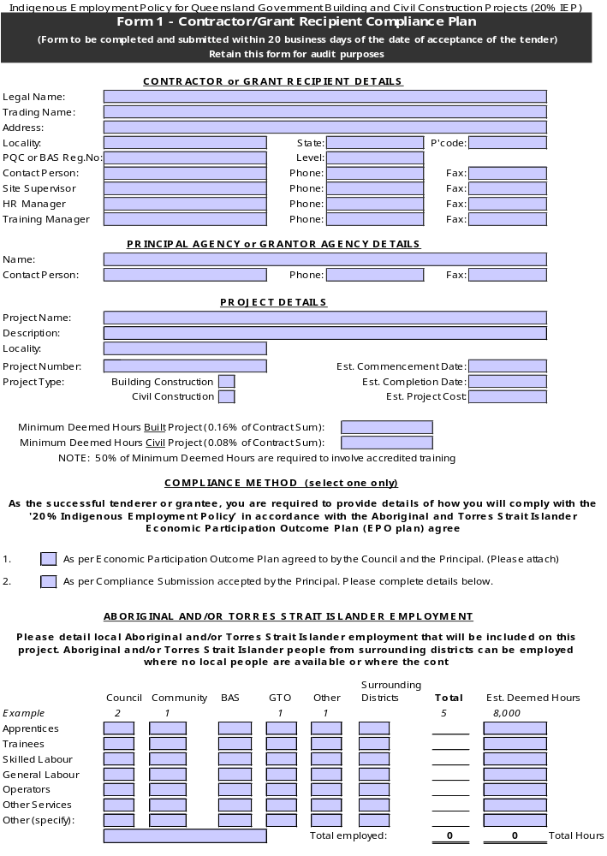

Form 1 - Contractor/Grant Recipient Compliance Plan 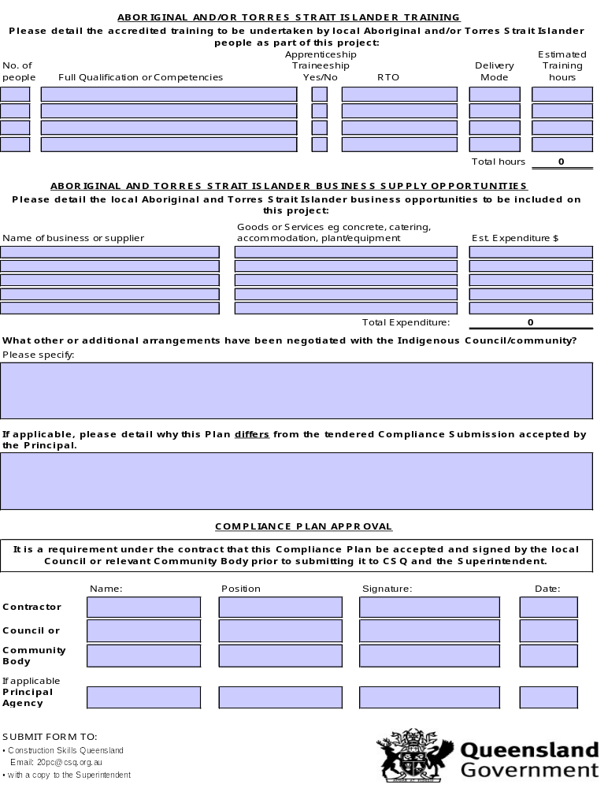

SCHEDULE 3 (continued)

STATUTORY DECLARATION
(To be completed and submitted prior to making a payment claim)

STATUTORY DECLARATION BY CONTRACTOR
Oaths Act 1867
Queensland
To Wit
I, of

in the State of Queensland, do solemnly and sincerely declare that, in relation to the Contract between the State of Queensland through

(the Principal) and

(the Contractor) for
(the Contract)

- I hold the position of
I am in a position to know the facts contained herein and to bind the Contractor by the terms of this declaration and I am duly authorised by the Contractor to make this declaration on its/their behalf.
- The Contractor has complied with the obligations set out in clause 9 of the Conditions of Contract.
- The details provided in the Interim Compliance Report/s dated …………….., setting out the Contractor’s monthly progress of compliance with the Indigenous Employment Policy for Queensland Government Building and Civil Construction Projects and the Compliance Plan, are true and correct as at the date of this declaration.
- The Interim Compliance Report/s dated …………….., was provided to Construction Skills Queensland in accordance with the Contract.

And I make this solemn declaration conscientiously believing the same to be true and by virtue of the provisions of the Oaths Act 1867.

TAKEN AND DECLARED before me )
)
)
)
)
^{(Name in full)} ) ^{Contractor}
at )
)
in the State of )
)
this day of 20 ) A Justice of the Peace/ Legal
) Practitioner/ Commissioner for
) Declarations

SCHEDULE 3 (continued)

INTERIM COMPLIANCE REPORT
(To be completed and submitted within 5 Business Days of the first day of each month)

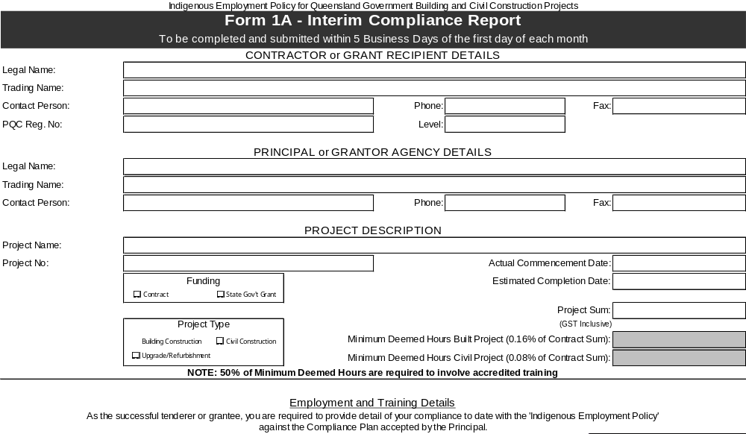
Form 1A – Interim Compliance Report – Continued
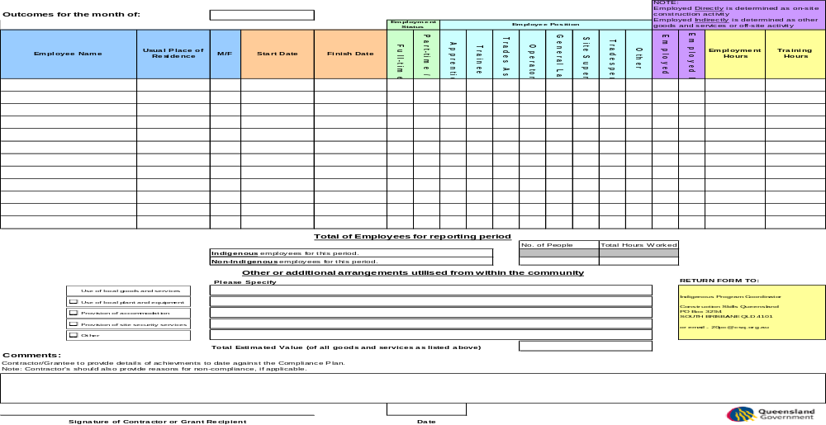

SCHEDULE 3 (continued)

PRACTICAL COMPLETION REPORT
(To be completed and submitted within 10 Business Days of the Date of Practical Completion, or if there is more than one, the last occurring Date of Practical Completion)

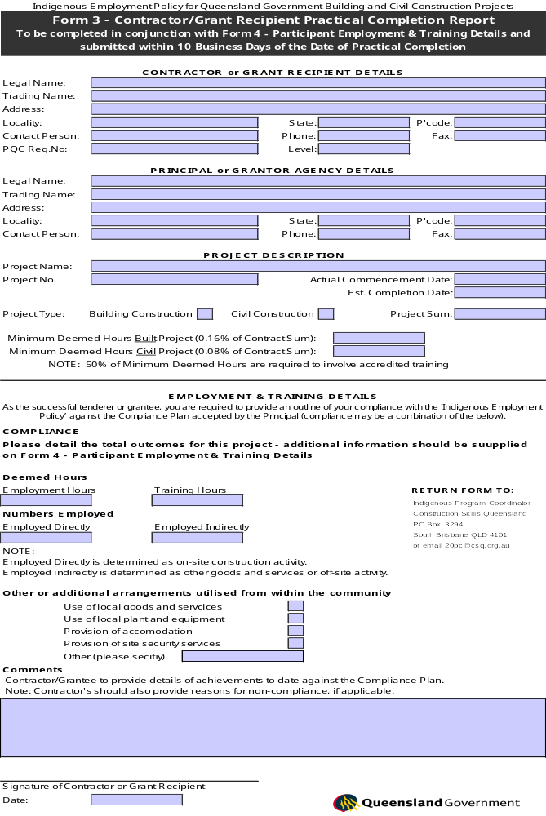

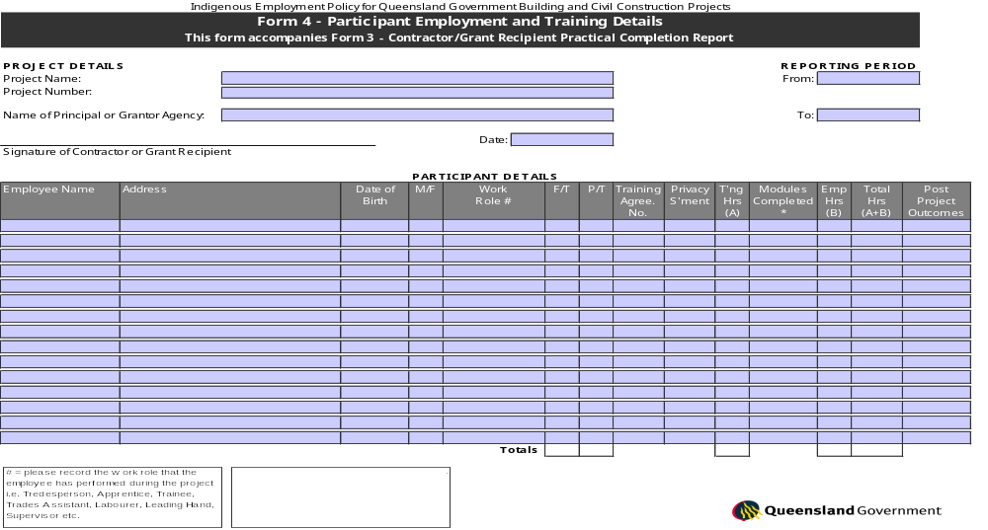


SCHEDULE 4

Statutory Declaration by Contractor

Oaths Act 1867
Queensland
To Wit

I, of

in the State of Queensland, do solemnly and sincerely declare that, in relation to the Contract between the State of Queensland through

(the State) and

“the Contractor” for
(the Contract).

- I hold the position of
I am in a position to know the facts contained herein and to bind the Contractor by the terms of this declaration, and I am duly authorised by the Contractor to make this declaration on its/their behalf.
- All subcontractors and sub subcontractors performing work under the Contract have been approved by the Superintendent in accordance with clause 3.

- All the Contractor's workers who at any time have been engaged on work under the Contract by the Contractor have been paid, in accordance with the relevant award or industrial instrument, all moneys due and payable to them up to the date of submission by the Contractor of Payment Claim No………….

- All subcontractors of the Contractor have been paid all that is due and payable to them up to the date of
submission by the Contractor of Payment Claim No in respect of their part of the work under the Contract.
- The Site Personnel Register maintained in accordance with clause 8 of the conditions of contract is current and correct.
- All subcontractors and sub subcontractors performing work under the Contract have been informed of the existence of the Building and Construction Industry Payments Act 2004 and the Subcontractors’ Charges Act 1974.

And I make this solemn declaration conscientiously believing the same to be true and by virtue of the provisions of the Oaths Act 1867.

TAKEN AND DECLARED before me )
)
)
)
)
(Name in full) ) Contractor
at )
)
in the State of )
)
this day of 20 )
A Justice of the Peace/ Legal Practitioner/
) Commissioner of Declarations
[Suggested information to pass on to Subcontractors and sub subcontractors]

IMPORTANT INFORMATION FOR SUBCONTRACTORS

The Queensland Government has enacted the following legislation to assist in providing security of payment and timely payments for subcontractors in the building and construction industry:

- Building and Construction Industry Payments Act 2004
- Subcontractors’ Charges Act 1974
Further information on these Acts, including Subcontractors’ Charges Act approved forms, can be accessed on the Queensland Building and Construction Commission website at http://www.qbcc.qld.gov.au.
Additional information on the Building and Construction Industry Payments Act can also be accessed on the Building and Construction Industry Payments Agency website at www.bcipa.qld.gov.au.

SCHEDULE 5

Approved Form of Undertaking

CONTRACT for [Drafting note: description as per letter of acceptance] (“the Contract”)
At the request of [Drafting note: Contractor as per letter of acceptance] (“the Contractor”)
and in consideration of [Drafting note: Principal as per contract annexure] (“the Principal”)
accepting this undertaking, [Drafting note: insert the financial institution’s details]

(“the Financial Institution”) unconditionally undertakes to pay on demand any sum or sums which may from time to time be demanded by the Principal to a maximum aggregate of $
( ) (“the Sum”)

The undertaking is to continue

(i) until notification has been received from the Principal that the Sum is no longer required by the Principal; or
(ii) until this undertaking is returned to the Financial Institution; or
(iii) until payment to the Principal by the Financial Institution of the whole of the Sum.

Should the Financial Institution be notified in writing, purportedly signed by or on behalf of the Principal that the Principal desires payment to be made of the whole or any part or parts of the Sum, such notification to be delivered to any branch of the Financial Institution located within Australia, it is unconditionally agreed that the Financial Institution will make payment or payments to the Principal forthwith without reference to the Contractor and notwithstanding any notice given by the Contractor not to pay same.

Provided always that the Financial Institution may at any time without being required so to do pay to the Principal the Sum less any amount or amounts it may previously have paid under this undertaking or such lesser sum as may be required and specified by the Principal and thereupon the liability of the Financial Institution hereunder shall immediately cease.

The Principal shall not assign or transfer its rights under this undertaking.

Dated at day of 20

SIGNED for and on behalf of (Financial Institution)

By its Attorney(s)

(Names)

Pursuant to Power of Attorney No )
who hereby warrant that he has/they have not received )
notification of revocation of his/their appointment. ) Attorney

in the presence of - )
Witness

Branch of Issue: Telephone:

A copy of AS4120-1994 is available for perusal at the office of the Principal.

