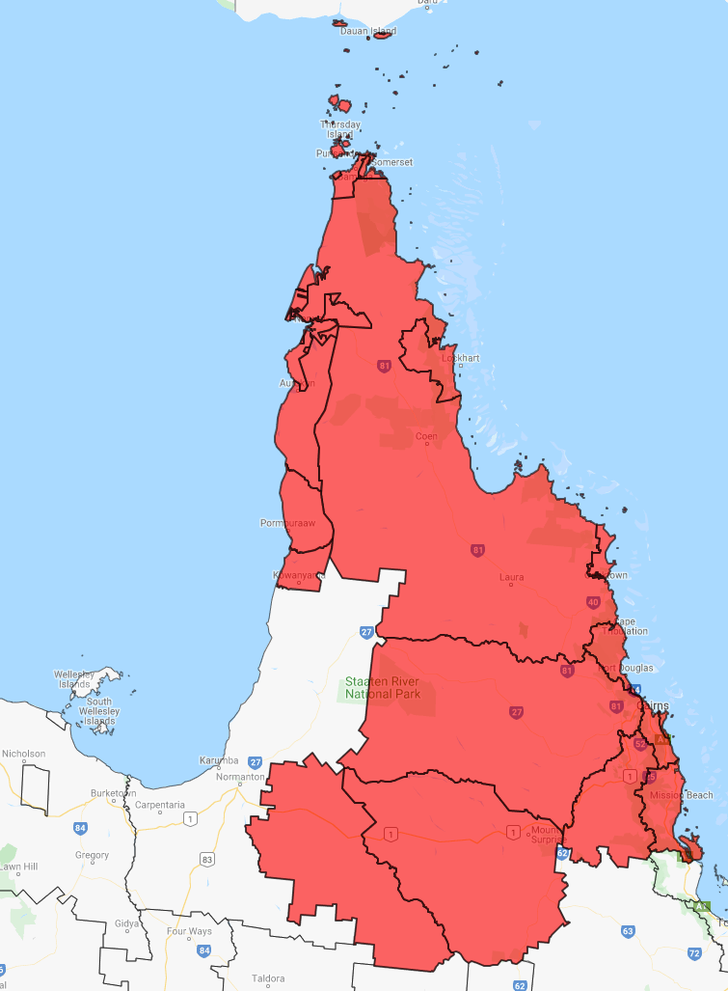

**Kezia Vonarx**   
Senior Community Recovery Officer   
[kezia.vonarx@communities.qld.gov.au](mailto:kezia.vonarx@communities.qld.gov.au)   
T: 07 4255 7046 M: 0427 101 524   
Level 2, 5B Sheridan Street, **Cairns**, QLD 4870

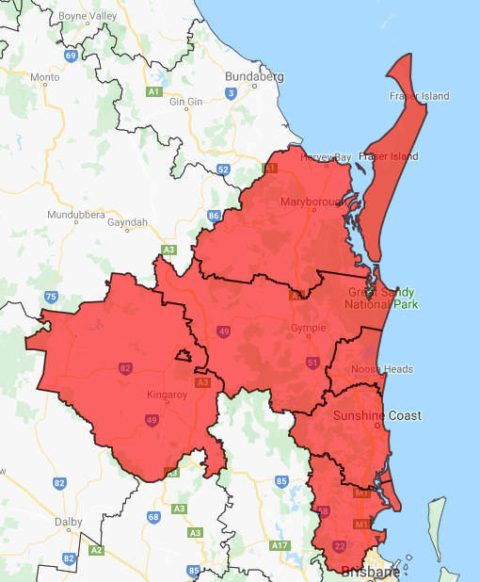

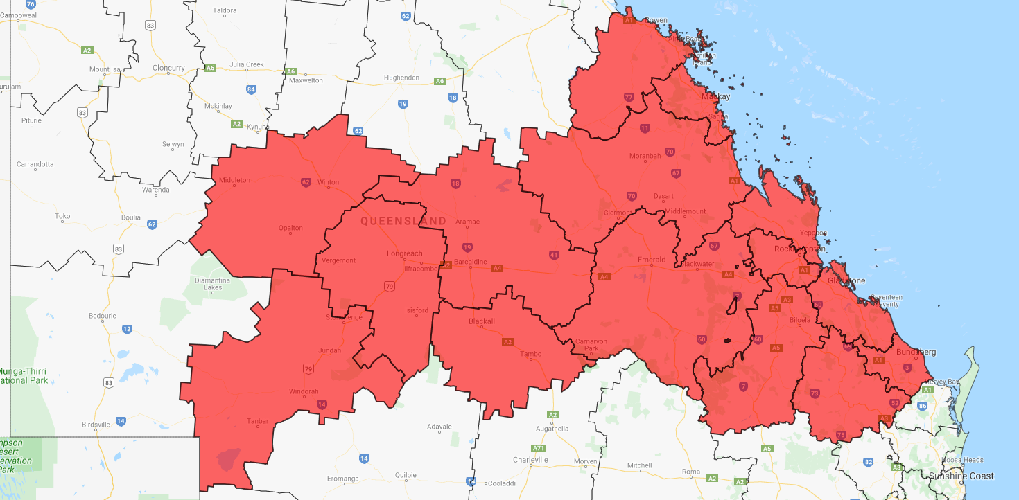

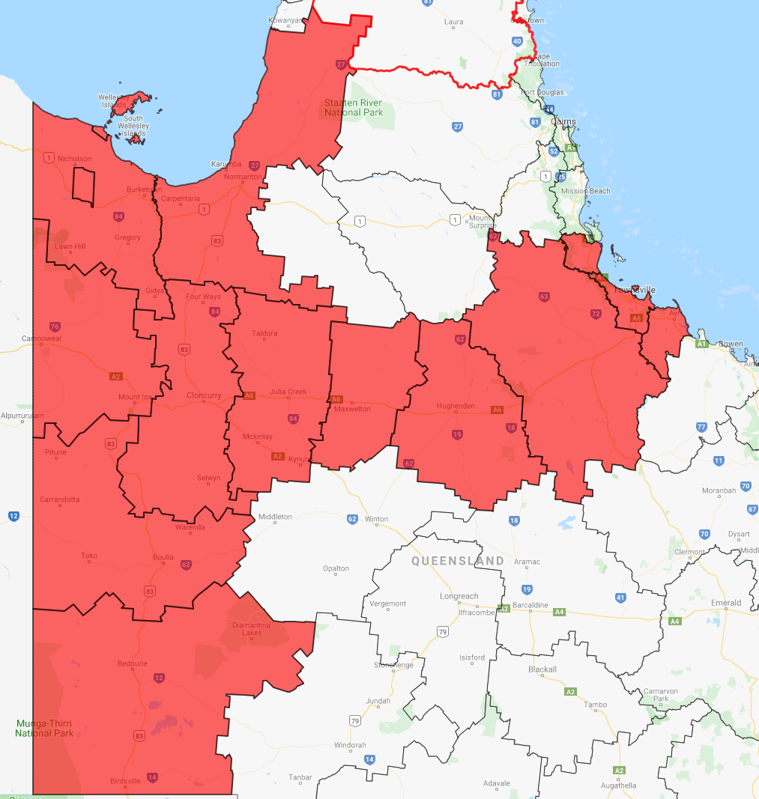

**Chantal Devereaux-Larkin**   
Senior Community Recovery Officer,   
[Chantal.Devereaux-larkin@communities.qld.gov.au](mailto:Chantal.Devereaux-larkin@communities.qld.gov.au)   
12 First Ave, **Maroochydore** Qld 4558.  
T: 07 5476 9629 | M: 0477 762 624

**Eric Boardman**   
Principle Community Recovery Officer   
[eric.boardman@communities.qld.gov.au](mailto:eric.boardman@communities.qld.gov.au)  
Level 4, 36 East Street,   
**Rockhampton** 4700  
**T**: 07 4848 4337 | **M**: 0428 113538

**Sharon Galeano**   
Senior Community Recovery Officer  
[Sharon.Galeano@communities.qld.gov.au](mailto:Sharon.Galeano@communities.qld.gov.au)  
T: 07 4796 6529 | M: 0427 145 601  
Level 8 Verde Towers, 445 Flinders Street, **Townsville** QLD 4810

**Marketa Chlebova**   
Senior Community Recovery Officer [Marketa.Chlebova@communities.qld.gov.au](mailto:Marketa.Chlebova@communities.qld.gov.au)   
55 Russell Street **South Brisbane** 4101  
T: 3097 0359  | M: 0407 577 640

Karla Keough   
Senior Community Recovery Officer  
[karla.keough@communities.qld.gov.au](mailto:karla.keough@communities.qld.gov.au)  
Level 11, The Rocket, 203 Robina Town Centre Drive **Robina** QLD 4226

T: 5656 5829 | M: 0437 274 170

**Annabelle Johnstone**   
Senior Community Recovery Officer  
[annabelle.johnstone@communities.qld.gov.au](mailto:annabelle.johnstone@communities.qld.gov.au)  
Level 2, 117 Brisbane St **Ipswich** Q 4305T: 3432 1342 | M: 0477 311 673

